### Goal

Build a system to generate an e-commerce site for the Armada’s partner beauty salon.

### Background

[Armada](https://www.armada-style.com/products/) is a beauty product manufacturing company producing a wide range of products such as shampoo. They are distributing their products through multiple channels; their own ecommerce website, drug stores and their partner beauty salon.

This time, to expand their business, they started a new distribution method, which is to build an ecommerce website for their partner beauty salons so that the salons can sell Armada's products online to their own customers. The diagram below illustrates the relationships among the partners.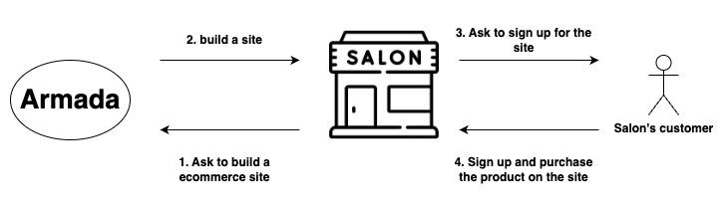

Armada currently has thousands of salon partners across Japan and is building the website for each of them. Though this development process is a simple and repetitive task; register a salon, pick the products to list on the site, generate the same format of html and css files, and deploy on their server, most of them are manually processed. So they want to automate them to scale faster.

### As-Is

Below are the current workflows to build the site.

1. The salon submits [the request form](https://www.armada-style.com/1113/ae_direct_entry/) and [the payment form](https://www.armada-style.com/1113/bbc_entry_account/) to Armada to open the ecommerce website.
2. Armada registers the salon information provided at the step 1 on the third-party ecommerce system, [楽楽BBC(Rakuraku BBC)](https://raku2bbc.com/) manually.
3. The salon submits the [listing item form](https://www.armada-style.com/1113/bbc_entry_product2/) to select the Armada products they want to list on their shop page.
4. Armada, given the step 3, starts to create the shop page, manually editing [their html and css templates](https://drive.google.com/drive/folders/12kz_e7cBbR5PdP9_TcGqHsG7TsR6PoVs?usp=drive_link).
5. Armada deploys the files created at step 4 to their server.

Not only does this take a few days to launch each shop page, but also Armada needs to manually maintain the pages every time any changes are made on the salon side.

### To-Be

Create the dashboard for the salon to manage their shop page by themselves.

#### User workflow

The below explains the steps from users’ point of view.

1. Salon creates an account with username and password.
2. Salon logs in to the dashboard to input salon information and items they want to list on their shop page.
3. Salon clicks the ‘Publish the shop page’ button.

#### Features

The Armada salon accounts have access to different types of features.

* Features in salon account
  + Salon information: Manage salon information
  + Product listing: Edit which products to be listed on the shop page.
  + Publish: Click publish button to push the change to shop pages in production.

#### Internal workflow

How it’s working internally. Since Armada uses RakurakuBBC as a cart system, the information registered on the dashboard needs to be automatically registered to RakurakuBBC through RakurakuBBC API.

##### When the salon creates a new account

When a salon asks Armada to open the shop page, Armada staff manually creates an URL with a parameter for each salon and share the URL for them to sign up.

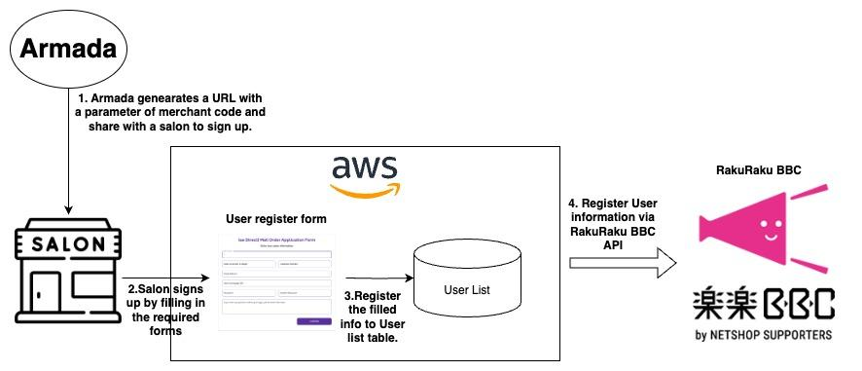

Check [the original](https://app.diagrams.net/#G1ea4Yx-j8Cl0cCWvqwakO9i54f3xnalWC#%7B%22pageId%22%3A%221KO8X_aLJjxugZOCiCoa%22%7D) for bigger texts.

The steps to sign up are as below.

1. Armada staff manually generates an URL with a salon code parameter. The salon code is taken from the partner salon list table which is managed by a different system.
2. Armada Staff sends the link generated at step 1 to the salon.
3. Salon fills in the onboarding page and clicks “Create an account”.
4. The backend system verifies if the salon code exists and there are no existing accounts with the same salon code in RakuRaku BBC.
5. If successfully verified, it creates a new account and registers to the user list DB table and RakuRaku BBC.
   1. In the backend, the system associates the salon code with the company code and company name.
   2. Also, the system needs to generate URL for the shop page and register it to `url` section in the [salon registration](https://shop.armada-style.com/admin/member/plg_raku2_member_edit.php).

The list below shows the required fields on the onboarding form.

* サロン名：salon name
* 郵便番号：post code
* 住所：address
* 電話番号：telephone number
* 代表者名：Representative Name
* 代表者名（フリガナ）：Representative name (in hiragana)
* メールアドレス：email address
* パスワード：password

##### When the salon account forgets the login information

When the salon forgets the login information and can not login to its account. It clicks the “Forgot your password?” text and input the email address it created the account with. Then, an email to change the password is sent to the email address. The salon clicks the link to open the password change page.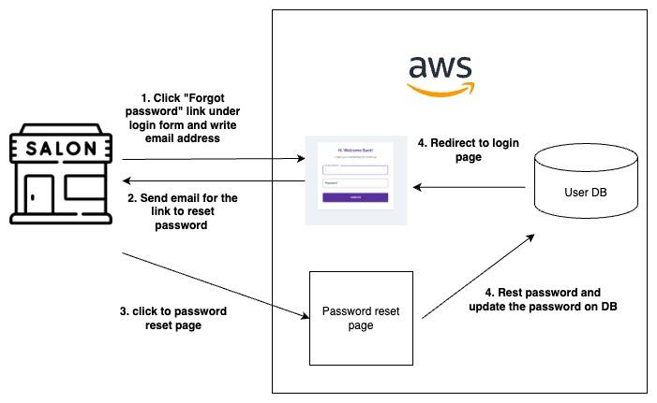

Check [the original](https://app.diagrams.net/#G1ea4Yx-j8Cl0cCWvqwakO9i54f3xnalWC#%7B%22pageId%22%3A%22KQ12LstfCsrp-czB5Gl8%22%7D) for bigger texts.

##### When the salon account updates the profile

After the signup/login, the salon top page is the profile page. It shows the list of profile information forms that the salon is required to fill in. Which forms to be listed will be determined later but it will be; salon name, the name of person in charge, etc…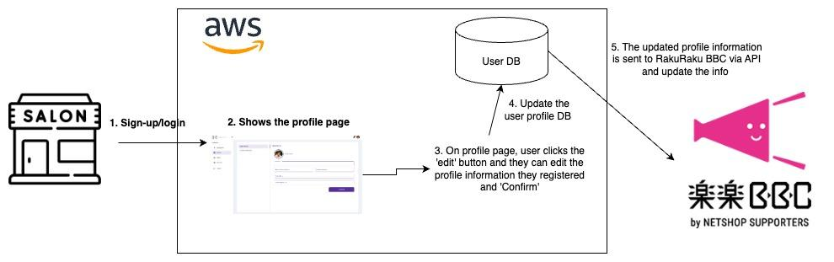

Also, in the profile edit page, salon should be able to upload the salon logo image which is going to be displayed on the header of the shop page. When no logo is uploaded, the salon name image should be displayed in the shop page header.

Check [the original](https://app.diagrams.net/#G1ea4Yx-j8Cl0cCWvqwakO9i54f3xnalWC#%7B%22pageId%22%3A%22IqSlxp_d8v0tFrMaNloQ%22%7D) for bigger texts.

##### When the salon account updates the product listing page

Every shop can list only Armada’s products on its shop page but it can select which products to be listed on the page. When the salon adds or deletes the product on their dashboard and publishes the update, it should dynamically modify the shop page’s html files which are uploaded on [Sakura Rental Server](https://rs.sakura.ad.jp/lp/bestplan-a/?gad_source=1&gclid=Cj0KCQjwmOm3BhC8ARIsAOSbapXORCnMjLmRNQyE5wGX2JKS0KLUvDHcF5C9CVYn7zW-MATI4BH7twkaAkeqEALw_wcB). Refer to [this Google Drive folder](https://drive.google.com/drive/folders/12kz_e7cBbR5PdP9_TcGqHsG7TsR6PoVs) for the actual html samples.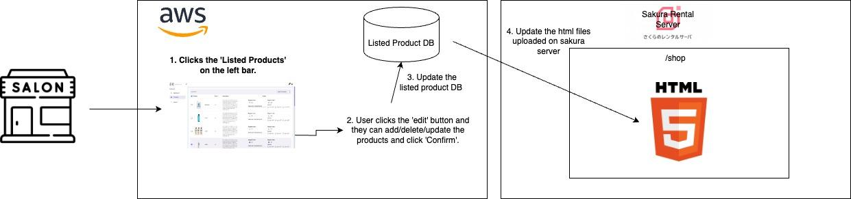

Check [the original](https://app.diagrams.net/#G1ea4Yx-j8Cl0cCWvqwakO9i54f3xnalWC#%7B%22pageId%22%3A%22YXmxFPYpPlCDPq-q9Q6p%22%7D) for bigger texts.

##### When Armada admin accounts edit the product list

To Be Discussed with the client again.

##### 